Title of your presentation for ISEM2024

FirstName FamilyName* and FirstName FamilyName**

*Affiliation, Address, Country
**Affiliation, Address, Country
E-mail : E-mail@corresponding.author

Abstract
All prospective authors for Oral Presentation and Poster Presentation should submit A4 one page abstract with one or two optional figures or tables as per the online procedure on the website by 24 May, 2024: http://www.jes.or.jp/isem/2024/submissions/abstract.html
For the topic of the prospective presentation, please choose from the following list of topics: http://www.jes.or.jp/isem/2024/overview/topics.html
The accepted abstracts will be included in the ISEM2024 abstract book and be reviewed by the program committee.
The Japan Explosives Society (JES) is a leading academic organization for energetic materials in Japan and an active forum for engineers and researchers from industry, academic institutions, and government agencies. The Science and Technology of Energetic Materials (STEM) is the official journal of the JES. STEM, which was first published as Kayaku Kyokai Shi (Journal of Explosive Association in Japanese) in 1939, became an international journal in 2003 as STEM. It is now an open-access journal, publishing six issues a year. STEM is one of the few international journals on explosives.
JES welcomes all speakers in ISEM2024 to submit papers for STEM. Normally, STEM charges publishing fee for paper processing, however, author of presentations in ISEM2024 receive exemption from publishing fee. In addition, selected papers from submitted ones will be awarded “The Best Paper Award” Don't miss this opportunity to submit your paper.
Submitted manuscripts will be peer-reviewed according to the journal standards. Please check the website for details: http://www.jes.or.jp/mag_eng
The deadline for paper submissions by ISEM2024 speakers is December 28, 2024.

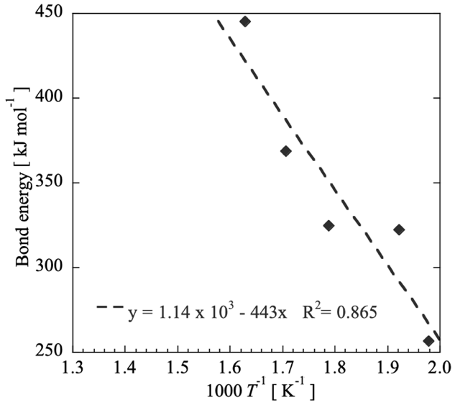
Figure 1 Relationship between bond energy and onset temperatures^{1), 2)}.

References
1) M. Kayaku, H. Bakuhatsu, and M. Anzen, Sci. Technol. Energ. Mater., 78, 550-560 (2017).
2) M. Kayaku, H. Bakuhatsu, and M. Anzen, Sci. Technol. Energ. Mater., 78, 1, 550-560 (2017). doi: 10.34571/stem.78.1_550.

