INFORMATION MESSAGE

INTERNATIONAL WORKSHOP
High Energy Materials: Demilitarization, Antiterrorism and Civil Application (HEMS-2012)
Gorniy Altai, Russia, September 5-7, 2012
  JSC FR & PC ALTAI,  Biysk, Russia | 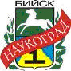  Administration,  Biysk-Naukograd, RF |   IPCET SB RAS,  Biysk, Russia

INTERNATIONAL COMMITTEE

Alexander Zharkov (Russia), Herve Graindorge (France), Alexander Vorozhtsov (Russia), Yuriy Mikhailov (Russia), Valentin Parmon (Russia), A. Subhananda Rao (India), Bikash Bhattachariya (India), Haridwar Singh (India), Gennady Sakovich (Russia), Vasiliy Fomin (Russia), Christian Perut (France), Keiichi Hori (Japan), Guy Jacob (France), Bernie Kosowski (USA), Yuriy Solomonov (Russia), Wilhelm Eckl (Germany), Sergei Sysolyatin (Russia), Sergei Kryzhanovskiy (Russia), Andrey Litvinov (Russia), Yevgeniy Maksimov (Russia).

OBJECTIVES AND SUBJECT AREAS PROPOSED
This International Workshop will be devoted to the analysis of the present state, advanced research and the practical use of high energy materials in civil application and antiterrorist activities.
This International Workshop is organized by JSC Federal Research & Production Center ALTAI and the Institute for Problems of Chemical and Energetic Technologies SB RAS for the purpose of promoting and consolidating the collaboration of leading international researchers, designers and manufacturers in the field of developing novel articles based on high-energy materials. The meeting format favors detailed discussions among participants of the topics they are interested in.
The topics selected for the Workshop cover problems of HEMs used in civil applications, antiterrorist activities, present state and perspectives of the following directions:
- Development of HEMs, Their Features, Diagnostics and Combustion;
- Demilitarization/Utilization/Environmental Safety of Energetic Systems;
- Rocket Motors for Space Systems, Gas Generators;
- Nanoscience and Nanotechnologies (including medicine and pharmaceutics);
- High Energy Materials for Antiterrorist Purposes;
- Dual-Purpose Chemical Substances and Medical and Biologic Materials.

PRELIMINARY WORKSHOP PROGRAM

04.09.12 | Tuesday | Arrival | Check-in and accommodation
05.09.12 | Wednesday | First day | Check-in at the Workshop, opening session, working session, photo
06.09.12 | Thursday | Second day | Working session, poster papers, closing session, gala dinner
07.09.12 | Friday | Third day | Guided tour, participants departure

PARTICIPATION FEE AND ACCOMMODATION COST

The participation fee for HEMs-2012 includes: information and accounting support, three meals a day and coffee-breaks during working sessions, gala dinner and costs for collection of theses, photo.

Russian reporters/representative/ observers 15,000 rubles
Russian postgraduates 7,000 rubles
Foreign reporters/representative/ observers € 400
Foreign postgraduates € 200

The Workshop will last three days and take place at the “Ivolga” camp (the Chemal Area, the Republic of Altai), located in the taiga woodland on the bank of the mountain river Katun (60 km away from Gorno-Altaisk and 160 km from Biysk).
The Workshop participants’ accommodation is expected to be in comfortable rooms at the “Ivolga” camp. The accommodation cost is not included in the participation fee.
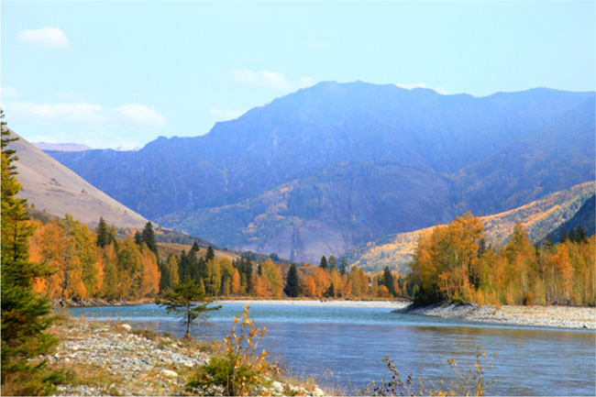

SHEDULE AND DEADLINES

Working language – Russian and English.
Abstracts and reports should be written in Russian and in English languages.

Receipt of abstracts (1-2 pages) | until May 1, 2012
Participation notification | until June 1, 2012

Russian reports should be sent with expert opinion.
You are requested to use in your reports MS Word Processor, Times New Roman, 14.

Prospective reporters are requested to send an electronic copy of
their abstracts to the contact address:
frpc-altay@mail.biisk.ru

Mail address of the Organizing Committee:
JSC Federal Research & Production Center ALTAI
Russia, 659322, Biysk, 1, Socialisticheskaya St.,
Fax +7-3854-311309

ORGANIZING COMMITTEE AND CONTACT PERSONS
Andrey Litvinov, Sergey Kopytov, Alexandra Litvinova, Olga Korzhevskaya

Alexander Chernov tel. +7−3854−305930
Olga Stolyarova tel. +7−3854−305826

